EER to Relational Model Steps:  
  
Step 1:

Step 2:

Step 3:

No 1:1 relations.

Step 4:

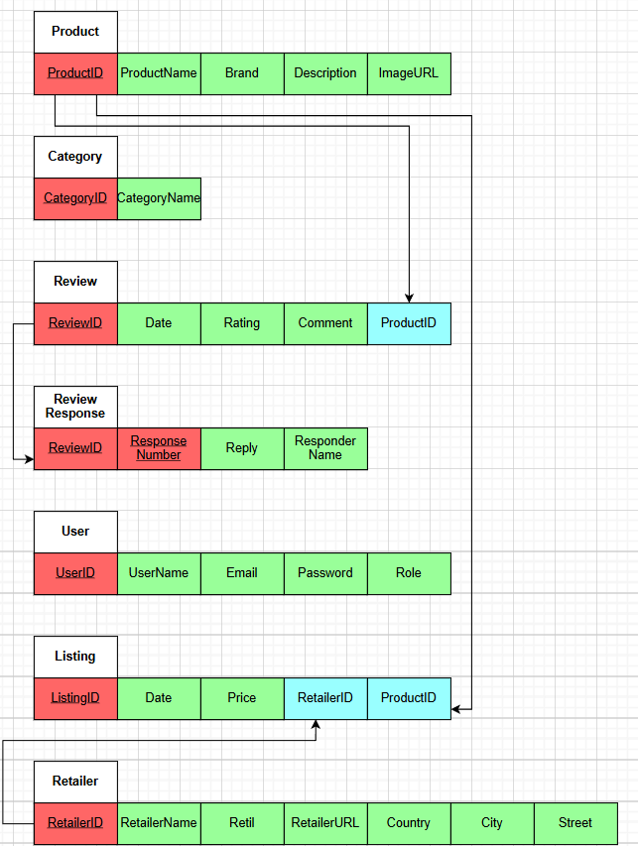

Step 5:

Step 6:

No multivalued attributes.

Step 7:

No M:N relations.

Step 8:  
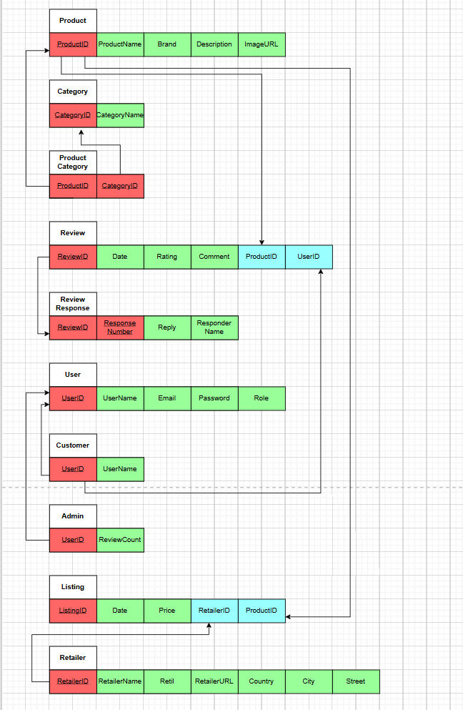

Step 9:  
No union types.